

Final Project
Master’s in Electrical and Microsystems Engineering

Group Members

Muhammad Hamzah 341192
Naeem Khanzada 3407332

Project Supervisor

Edge AI Radar Feasibility

Author

Muhammad Hamzah 3411924
Naeem Khanzada 3407332

A Project in fulfillment of the requirements for the degree of Electrical and Microsystems Engineering

Project Supervisor

Certificate of Declaration
It is certified that the project work titled “Edge AI Radar Feasibility” is carried out at OTH University. It is in fully working condition, and a report for Project is submitted. Project work and report will not be submitted in any other form for controller degree or diploma at any university or any other institution for education and will not be submitted in future for obtaining any degree in any university.

Abstract

This project investigates the feasibility of deploying custom algorithm directly on radar hardware, focusing on the Infineon BGT60LTR11AIP and Texas Instruments IWR6843AOPEVM modules. The objective is to integrate a tiny ml model which can work autonomously on device, eliminating the need for continuous high bandwidth data streaming to external systems such as host PC. The Project will begin firstly establishing the theoretical foundations of FMCW radar operation, I/Q modulation, and essential signal processing techniques such as bandpass filtering, FFT, and STFT. Hardware constraints, including limited Flash memory, processing throughput, and real-time inference requirements, are analyzed to define model size and complexity limits. Data accessibility for each radar platform is evaluated, comparing raw, semi processed, and fully processed outputs to determine integration points for Detection inference. Multiple firmware level model integration strategies will be explored, including embedding inference into the DSP pipeline or running models on auxiliary MCU cores, with deployment options through toolchains such as TI’s Code Composer Studio and Infineon’s Developer GUI etc. Profiling results guide quantization, pruning, and conversion workflows to fit within the embedded compute envelope. The outcome is a structured roadmap for on board radar system with integration of tiny-ml model.

Table of Contents
Contents
Abstract 4
Table of Contents 5
1. Introduction: 6
2. Objectives: 6
3. System Overview: 6
4. Hardware and Software Requirements for Texas Instruments IWR6843AOPEVM 7
4.1. Hardware: 7
4.2. Software: 7
4.3. Architecture: 7
4.4. Methodology 9
4.5. Result: 9
4.6. Challenges: 9
5. Hardware and Software Requirements for Infineon BJT60TR13C DEMO VERSION 10
5.3. Architecture: 10
5.4. Methodology 12
5.5. Python Code for Presence Energy: 16
5.6. Comparison Table High/Low Presence Energy: 20
5.7. Utilization of Raw Data for ML Model: 22
5.8. Training and classification of ML: 25
5.9. Conversion of ML model for embedded Deployment preparation: 30
5.10. Result: 40
5.11. Headroom (flash memory and RAM) Utilization: 40
5.12. Challenges: 40
6. Future Work: 41
7. References: 42

Edge AI Radar Feasibility

Introduction:
Due to technological advancements, we can now execute custom algorithms directly on embedded hardware, resulting in processing that is low-latency and energy-efficient. On-device inference can help radar sensors like the Infineon BGT60LTR11AIP and TI IWR6843AOPEVM by removing the requirement for a host device and constant high-bandwidth data transmission. Taking into account hardware limitations, data accessibility, and model optimization techniques for applications like gesture recognition and presence detection, this project explores whether or not custom firmware and tiny ML models can be integrated into radar firmware to process signals in real time.

Objectives:
- Define System Requirements for both boards.
- Establish Communication Protocols.
- Customize Radar Configuration for custom chirps
- Develop Radar Decision Logic in c language
- Integrate Control Signal Output for led.
- Evaluate the overall system performance.
- Integration of Tiny-ml model

System Overview:
Our primary focus will be on custom firmware development for both boards, as they both are capable of executing complex code and acting as the programmable intelligence platform. which involves multicore programming of microprocessors, where we will implement custom algorithms and measure the processing speed and latency of our code and of boards. and we will analyse their datasheets to evaluate their electrical switching time against our application's requirements. our core output will be a comparative analysis proving which board provides essential and faster platform for running custom firmware.

Hardware and Software Requirements for Texas Instruments IWR6843AOPEVM

Hardware:
  - IWR6843AOPEVM (Development Board)

Software:
  - MMWAVESTUDIO.
  - UNIFLASH
  - CP210X (UARTserial drivers)

Architecture:
The Texas Instruments IWR6843AOPEVM is a compact, highly integrated 60-64 GHz mmWave sensor featuring an Antenna-on-Package (AOP) design. Its architecture integrates a complete FMCW transceiver (3 transmitters, 4 receivers) with a powerful multicore processing subsystem. This includes a 200 MHz Arm Cortex-R4F for control and object detection, a 600 MHz C674x DSP for advanced signal processing, and a specialized Hardware Accelerator (HWA) to manage computationally intensive tasks like FFTs and CFAR processing. This combination allows the IWR6843AOPEVM to function as a self-contained, low-latency, and high-accuracy radar system, ideal for industrial applications [1]
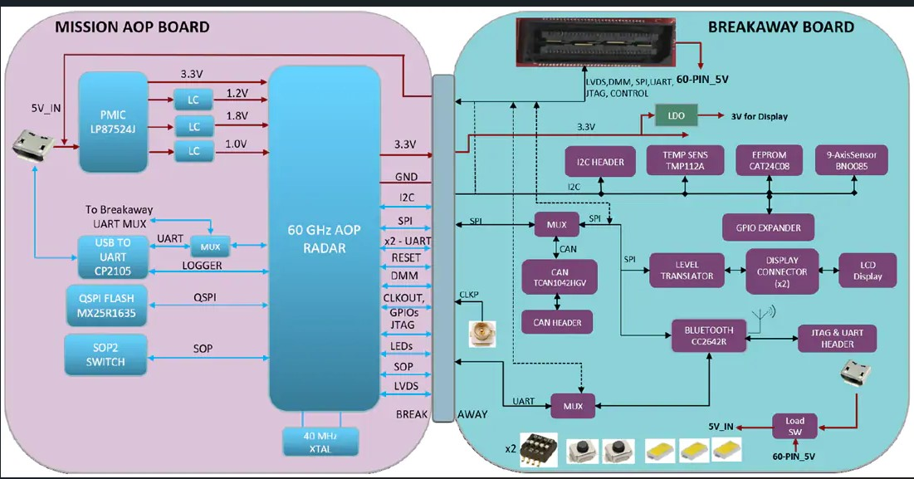

Fig. 1. BOARD ARCHITECTURE [https://e2e.ti.com/support/sensors-group/sensors/f/sensors-forum/1550892/iwr6843aopevm-i2c-address-for-iwr6843aop-chip][1]
FMCW Transceiver: A single-chip radio frequency (RF) front end that generates, transmits, and receives the Frequency Modulated Continuous Wave (FMCW) radar signal. It includes the PLL (Phase-Locked Loop), Transmitter (Tx), and Receiver (Rx) chains to convert signals between the RF and baseband domains.

Antenna-on-Package (AOP): The innovation where the radar transmits and receive antennas (typically 3 Tx and 4 Rx) are integrated directly onto the device package. This eliminates the need for external PCB antennas, significantly reducing the size and complexity of the final module.

Arm Cortex-R4F (MSS): The Microcontroller Subsystem (MSS) is the device's main control unit. It's responsible for configuring the radar front end, controlling peripherals, managing interfaces, and executing object detection algorithms. The 'F' indicates it has a floating point unit..[1]

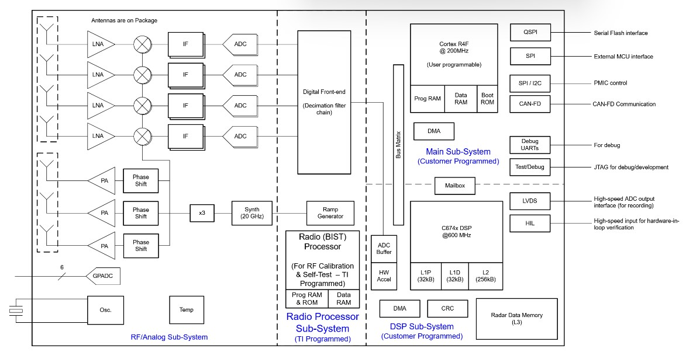
Fig. 2. IWR6843AOPEVM Block Diagram [https://www.ti.com/product/de-de/IWR6843][1]

  - Methodology

System Initialization
The IWR6843AOP Evaluation Module (EVM) connects to a PC via a single USB cable, which serves a dual purpose: it provides power to the board and establishes two virtual COM ports. These ports allow for configuration commands and the output of processed object data. the data is supposed to be further processed in MMwavestudio [2]
  - Result:
In order to successfully collect raw Analog-to-Digital Converter (ADC) data from the IWR6843AOP Evaluation Module (EVM), the DCA1000EVM Capture Card is the single required component beyond the sensor board itself and a PC. the standard USB needs a bridging hardware such as The DCA1000EVM which receives the high bandwidth LVDS data from the IWR6843AOP and converting it into a format typically transmitted over Ethernet that a standard PC can receive and store in a binary file under the control of mmWave Studio.

  - Challenges:
- The mmWave Studio software we tried to use relies entirely on the DCA1000EVM's Ethernet connection to control the data flow and save the binary file. Without the DCA1000EVM, the acquisition path simply doesn't exist.

- The lack of a public, simplified data register configuration file. This necessitated relying entirely on the complex, abstract C-language APIs provided in the TI mmWave SDK to properly initialize the proprietary RF front end and clocking sequences, instead of direct register access which is required for custom firmware development.

- one of the major issue we faced was utilizing custom binaries required me to develop a custom host PC visualizer as the standard TI tools could not parse the specialized data format

Hardware and Software Requirements for Infineon BJT60TR13C DEMO VERSION
  - Hardware:
- Infineon BJT60TR13C Demo Version.
  - Software:
- Infineon Developer Center Launcher.
- Visual Studio Code.
- Bossa.
- Arm GNU compiler.
- python and various libraries

Architecture:
The BGT60TR13C demo version (EVM) is a complete, two-chip system built on a PCB to enable quick evaluation of the radar sensor. It centers around the BGT60TR13C MMIC, which functions as the dedicated 60 GHz radar frontend, containing the transceiver and ADCs to capture and digitize the environment. Since the chip lacks processing power, the EVM integrates a necessary external 32-bit Arm Cortex Microcontroller Unit (MCU) that receives the raw data via SPI and performs all the computationally intensive tasks, such as FFTs and application logic (e.g., presence detection which we will be utilizing it for). This architecture is completed by a connectivity section that includes a USB interface for power and for streaming the processed results to a host PC, along with various debug and test ports required for custom firmware development.

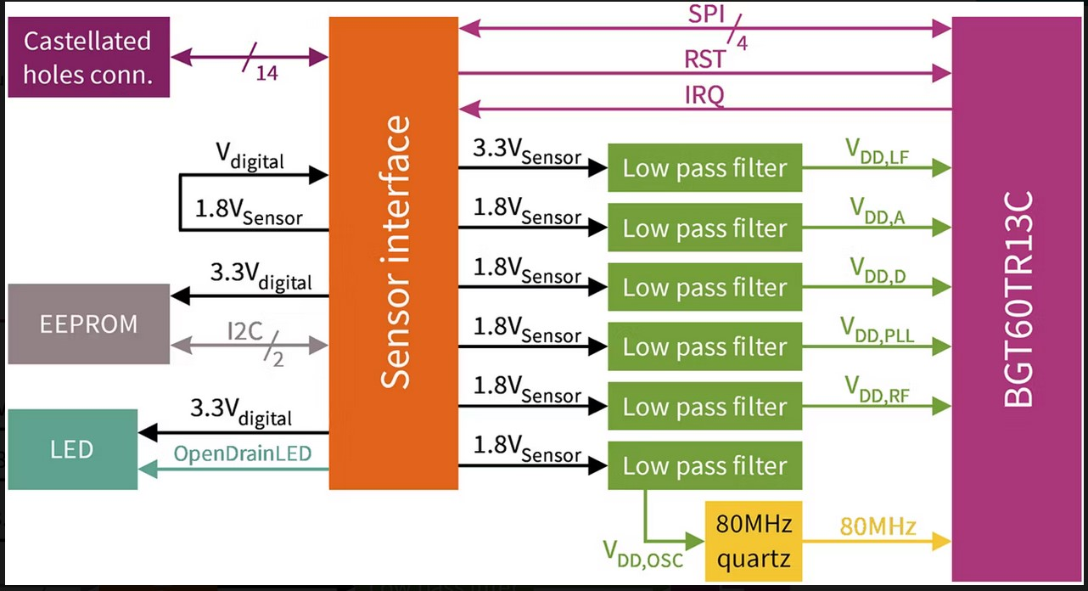
Fig.3. BGT60TR13C Board Architecture https://www.infineon.com/evaluation-board/DEMO-BGT60TR13C

BGT60TR13C MMIC: This is the core 60 GHz radar frontend chip (Monolithic Microwave Integrated Circuit). It contains the VCO/PLL, transceiver (1 Tx, 3 Rx), and ADCs. Its primary role is to capture the environment and output raw digital data

Antenna-in-Package (AIP): The transmit and receive antenna elements are integrated directly into the BGT60TR13C chip package. This eliminates the need for external PCB antenna design.

External Microcontroller Unit (MCU): A powerful ATSAMS70Q21 Arm Cortex processor (typically from Infineon's PSoC family) integrated onto the demo board. This is the intelligence component, responsible for all heavy processing, including FFTs, CFAR detection, and application logic, as the radar chip itself is passive.

SPI Interface: The high-speed Serial Peripheral Interface is the communication link between the BGT60TR13C chip and the external MCU, used to transfer the raw ADC data for processing.

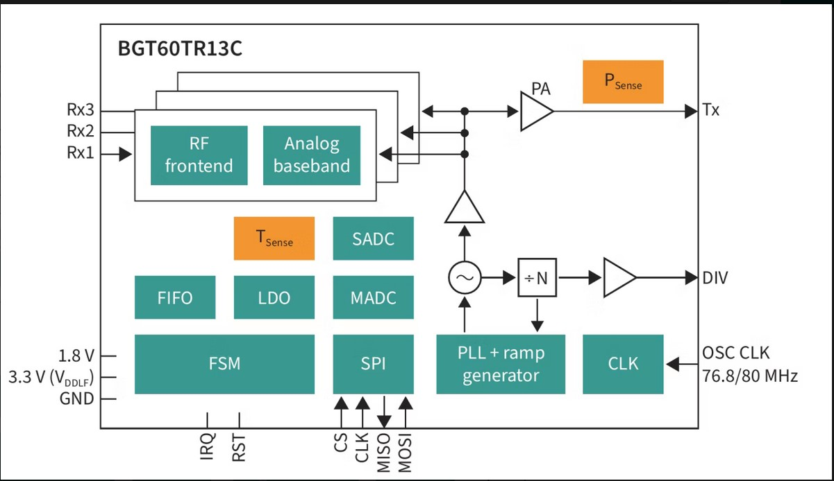
Fig.4. Block Diagram BGT60TR13C https://www.infineon.com/part/BGT60TR13C
  - Methodology

System Initialization
Initially in the project we commenced with an attempt at direct raw data acquisition from the sensor utilizing the Infineon Developer Tool and subsequent processing. This was strategically undertaken to bypass the inherent limitations of the visualization tool's pre-packaged output and secure the raw Analog-to-Digital Converter (ADC) data (I/Q samples). The configuration, verified by the GUI, specified the fundamental unit of measurement as the chirp, with each frame containing a sequence of 64 chirps, and each chirp consisting of 64 ADC samples. The corresponding terminal output confirmed the successful capture and parsing of this structured data stream, demonstrating that the custom script was correctly iterating through and printing the raw I/Q values generated by the sensor during these precise chirp cycles, which is crucial for subsequent offline custom signal processing algorithm development.
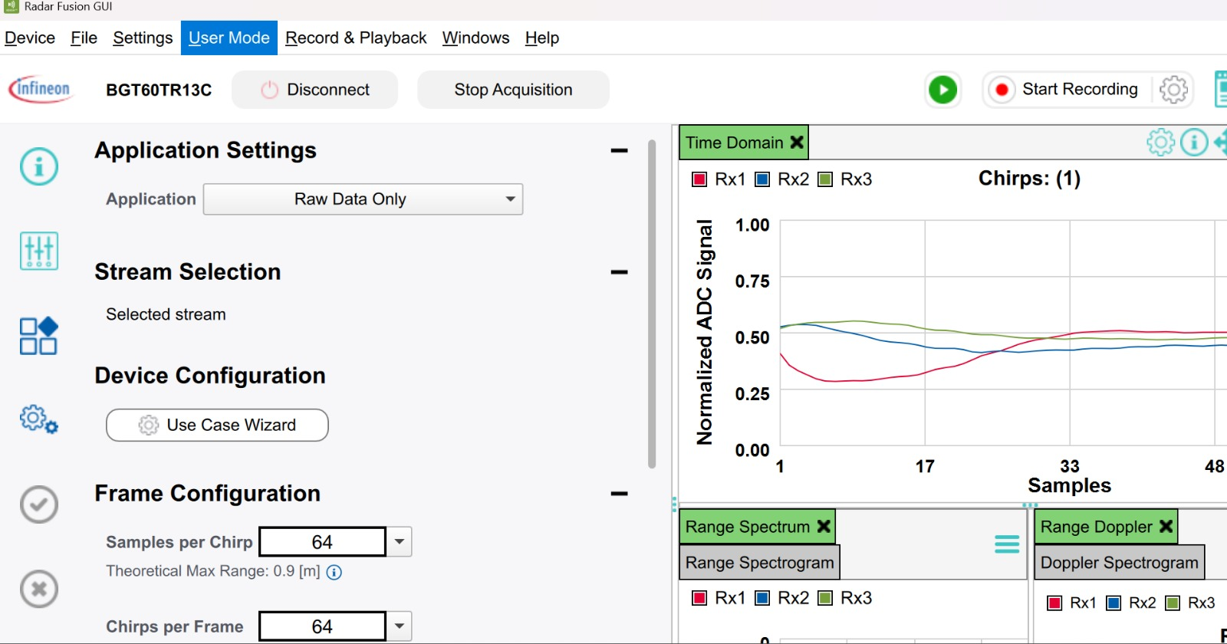
In the next the crucial step of acquiring and analysing raw data directly using Python, we used python to establish that the raw data can be extracted not only with Infineon GUI. This phase specifically involved bypassing the developer tool's graphical interface to secure the unprocessed Analog-to-Digital Converter (ADC) data (I/Q samples) stream into a programmatic environment. Custom Python scripts, utilized in conjunction with the Infineon SDKs, established a low-level communication link to directly receive the high-speed serial stream containing the raw ADC values generated by the BGT60TR13C frontend. The Python environment successfully parsed and validated the streamed data, confirming the packet structure aligned with the sensor's configured parameters of 64 samples per chirp and 64 chirps per frame. This direct, programmatic access to the raw data is essential for the independent development and precise tuning of proprietary signal processing algorithms specifically FFTs and CFAR detection by allowing for detailed analysis of the raw data's noise floor and clutter profiles before the optimized processing chain is deployed to the embedded microcontroller

Python Code:
import numpy as np

from ifxradarsdk import get_version_full
import ifxradarsdk.mimose as mimose
import ifxradarsdk.mimose.types as mimose_types
from mimose_plotter import MimosePlotter

print("Radar SDK Version: " + get_version_full())

# open device: The device will be closed at the end of the block. Instead of
# the with-block you can also use:
with mimose.DeviceMimose() as Dev:
# modify default configuration retrieved from SDK
Dev.config.FrameConfig[0].selected_pulse_configs[1] = True
#Dev.config.FrameConfig[0].selected_pulse_configs[2] = True
Dev.config.PulseConfig[1].channel = mimose_types.ifx_Mimose_Channel_t.IFX_MIMOSE_CHANNEL_TX1_RX2

# transfer configuration to device
Dev.set_config()

# create plot object
mimose_plot = MimosePlotter(Dev.config)
fcount = 1

while 1:
frame = Dev.get_next_frame()[0]
mimose_plot.draw(frame)
if not mimose_plot.is_open():
break
print('Got frame ', fcount, ', num pulse configs=', np.shape(frame)[1])
fcount = fcount + 1

mimose_plot.close()

Python script we used is designed for real time data acquisition and visualization from the Infineon Mimose radar sensor using the SDK. It begins by initializing and opening the radar device, then loads the default configuration to apply a custom modification: it enables a specific pulse configuration and sets it to use the TX1 and RX2 antennas. After transmitting this hardware configuration, the script enters an indefinite loop. Inside the loop, it continuously retrieves the next radar frame of data, renders this data using the MimosePlotter visualization tool, and logs the current frame count and the structure of the acquired pulses to the console. The process runs until the user manually closes the plot window, effectively serving as a framework for testing and observing custom radar settings in action.
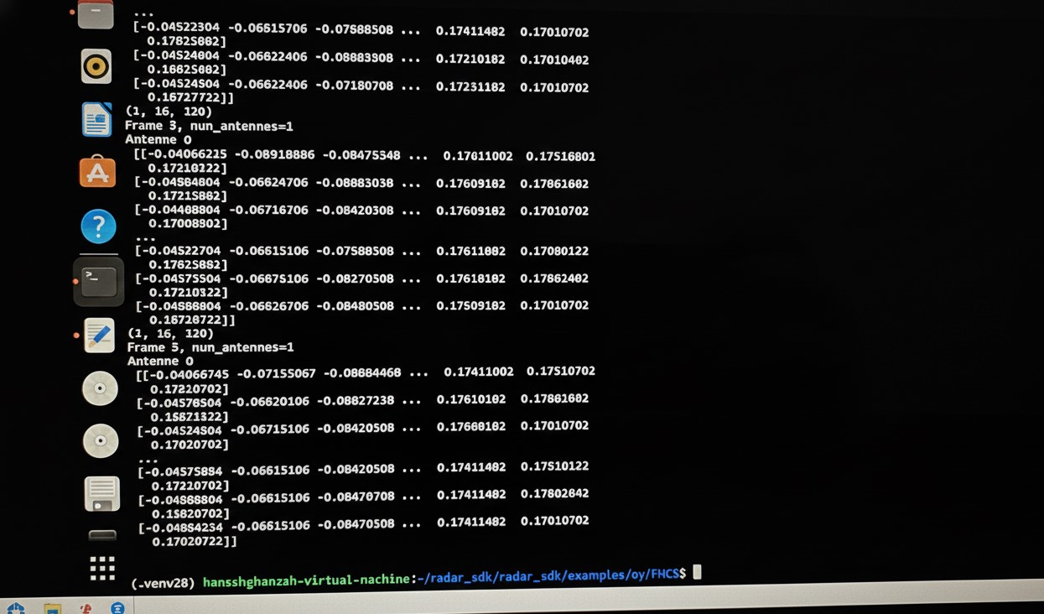
The output data illustrates successful acquisition of this raw, unprocessed data, which is the essential foundation of our project, as it provides the necessary input for subsequent offline development and precise tuning of custom signal processing algorithm in our application presence detection

Python Code for Presence Energy:
This code is intended to handle raw radar data in real time in order to log human presence information using an FMCW radar sensor. It computes a presence energy property from each received frame that reflects motion or activity in the radar's field of view, sets up the radar to execute Doppler range processing, and eliminates static clutter to suppress stationary reflections. While guaranteeing safe termination and dependable data preservation, the extracted presence energy is constantly logged to a CSV file for a predetermined logging duration, allowing offline analysis, visualization, or use as input data for presence detection or machine learning algorithms.
# ===========================================================================
# FMCW Radar Presence Detection Logger (FINAL, FIXED)
# - Range–Doppler processing
# - Static clutter removal
# - Presence energy feature per frame
# - 10 second logging duration
# - Graceful Ctrl+C handling
# ===========================================================================
import csv
import signal
import time
from datetime import datetime

import numpy as np
from ifxradarsdk import get_version
from ifxradarsdk.fmcw import DeviceFmcw
from ifxradarsdk.fmcw.types import (
FmcwSimpleSequenceConfig,
FmcwSequenceChirp,
)
# -------------------------
# Global control flag
# -------------------------
running = True
def handle_interrupt(signum, frame):
global running
print("\nInterrupt received. Stopping safely...")
running = False
signal.signal(signal.SIGINT, handle_interrupt)
# -------------------------
# Radar configuration
# -------------------------
config = FmcwSimpleSequenceConfig(
frame_repetition_time_s=307.325e-3,
chirp_repetition_time_s=500e-6,
num_chirps=64, # Required for Doppler
tdm_mimo=False,
chirp=FmcwSequenceChirp(
start_frequency_Hz=59e9,
end_frequency_Hz=61e9,
sample_rate_Hz=2e6,
num_samples=128,
rx_mask=1,
tx_mask=1,
tx_power_level=31,
lp_cutoff_Hz=500_000,
hp_cutoff_Hz=80_000,
if_gain_dB=30,
),
)
# -------------------------
# CSV setup
# -------------------------
timestamp = datetime.now().strftime("%Y%m%d_%H%M%S")
csv_filename = f"radar_presence_{timestamp}.csv"
csv_file = open(csv_filename, mode="w", newline="")
csv_writer = csv.writer(csv_file)
csv_writer.writerow([
"frame_idx",
"rx_idx",
"presence_energy",
])
# -------------------------
# Device acquisition
# -------------------------
with DeviceFmcw() as device:
print("Radar SDK Version:", get_version())
print("UUID of board:", device.get_board_uuid())
print("Sensor:", device.get_sensor_type())
sequence = device.create_simple_sequence(config)
device.set_acquisition_sequence(sequence)
frame_idx = 0
start_time = time.time()
LOG_DURATION_S = 20

print("\nLogging PRESENCE data for 10 seconds...\n")
while running and (time.time() - start_time) < LOG_DURATION_S:
frame_contents = device.get_next_frame()
for frame in frame_contents:
# frame shape: [rx, chirps, samples]
num_rx, num_chirps, num_samples = frame.shape
for rx in range(num_rx):
# -----------------------------
# 1. Static clutter removal
# -----------------------------
frame_rx = frame[rx, :, :]
frame_rx = frame_rx - np.mean(frame_rx, axis=0, keepdims=True)
# -----------------------------
# 2. Range FFT
# -----------------------------
range_fft = np.fft.fft(frame_rx, axis=1)
range_fft = range_fft[:, :num_samples // 2]
# -----------------------------
# 3. Doppler FFT
# -----------------------------
doppler_fft = np.fft.fft(range_fft, axis=0)
rd_map = np.abs(doppler_fft)
# -----------------------------
# 4. Presence feature
# -----------------------------
presence_energy = float(np.sum(rd_map))
csv_writer.writerow([
frame_idx,
rx,
presence_energy,
])
frame_idx += 1
csv_file.flush()
# Cleanup
csv_file.flush()
csv_file.close()
print(f"\nData logging complete. File saved as: {csv_filename}")
This script is intended to gather raw radar data in two controlled conditions: first in which there is no human presence and second in which there is. The radar records frames, logs a presence-related energy feature to a CSV file, and performs range-Doppler processing with static clutter removal during each run. A machine learning model for accurate radar-based presence detection may be trained and validated using these two datasets low presence energy and high presence energy which provide labelled instances.

Comparison Table High/Low Presence Energy:

High Presence Energy | Low Presence Energy
  3.136.799.591.266.150
  923.890.361.556.811
  9.317.224.966.258.790
  10.171.390.046.899.100
  1.472.493.385.909.320
  5.707.563.118.271.120
  15.145.076.374.051.000
  15.878.794.628.020.000
  4.597.075.707.835.740
  2.292.580.744.639.440
  10.711.795.006.682.700
  512.599.521.570.357
  4.515.532.843.419.870
  4.712.179.082.076.100
  4.922.931.254.646.620
  5.186.914.311.313.560
  9.225.042.720.450.910
  1.601.573.296.705.830
  1.916.612.962.497.930
  11.906.233.158.619.700
  17.836.204.210.805.000
  10.394.753.382.866.100
  9.643.433.920.523.080
  14.837.044.181.418.900
  17.467.470.726.811.600
  2.137.226.510.560.090
  17.493.493.667.252.700
  17.587.478.482.039.000
  248.299.174.786.519
  7.438.700.946.089.230
  19.266.337.746.045.400
  9.978.408.849.544.920
  13.699.750.525.504.500
  11.927.641.089.957.700
  1.037.404.534.756.430
  8.661.412.766.405.520
  11.695.358.693.183.800
  6.844.854.628.514.000
  13.875.875.468.834.300
  7.311.279.304.022.260
  6.412.372.759.655.870
  5.999.175.905.699.570
  7.426.291.759.192.310
  11.548.035.261.641.800
  123.886.853.060.389
  12.367.928.959.233.000
  13.490.559.285.168.400
  5.739.339.085.821.320
  14.280.211.215.345.900
  11.614.729.760.423.400
  2.229.585.336.683.970
  6.186.412.552.824.380
  2.672.954.458.658.030
  12.315.961.673.090.100
  22.336.647.084.245.400
  2.399.288.571.742.170
  10.870.018.034.653.800
  1.567.257.685.386.160
  14.068.566.543.165.300
  10.399.160.609.681.300
  9.407.512.462.333.040
  17.146.367.359.460.800
  1.579.637.893.365.170
  286.433.836.636.583
  1.764.503.660.458.540
  12.967.132.175.051.300
  2.839.444.221.714.720
  30.073.496.121.879.200
  31.216.157.884.195.400
  2.989.229.104.924.770
  2.826.248.461.849.540
  3.016.001.402.521.390
  3.066.338.815.037.730
  2.840.839.228.973.040
  2.810.760.160.335.310
  2.883.463.326.376.440
  2.751.420.037.845.270
  27.862.715.180.825.300
  2.913.782.501.521.840
  28.758.944.211.245.100
  29.628.828.930.699.700
  284.639.132.641.169
  28.233.845.225.505.600
  27.077.233.288.397.200
  26.775.963.128.515.200
  2.707.218.599.584.910
  2.749.958.244.918.400
  2.781.972.589.264.600
  27.552.740.567.484.400
  27.301.314.777.769.200
  2.661.742.235.989.400
  27.721.848.159.810.900
  27.506.694.586.654.100
  27.202.158.332.059.600
  2.777.496.594.922.810
  269.595.010.938.344
  27.162.999.561.483.200
  2.695.939.935.439.910
  26.848.108.781.339.500
  27.056.385.412.638.100
  26.989.622.938.258.100
  2.824.851.692.375.490
  27.453.119.959.757.200
  2.647.813.018.559.750
  2.628.879.790.944.970
  265.814.160.860.854
  27.206.297.014.107.000
  2.721.219.491.983.770
  2.750.770.984.413.090
  27.296.137.117.885.100
  265.839.358.296.974
  2.732.245.083.336.040
  2.754.279.294.943.350
  27.141.048.777.414.900
  27.136.671.267.876.100
  27.223.464.570.860.600
  27.558.872.221.656.200
  27.147.117.290.374.000
  2.696.390.987.279.810
  28.329.704.937.530.400
  28.131.822.617.029.900
  27.088.524.787.110.400
  27.437.918.197.741.300
  26.899.901.726.023.800
  2.691.065.331.466.460
  26.128.283.247.535.400
  273.542.026.518.861
  2.657.305.281.844.290
  26.432.771.287.618.000
  2.721.764.219.548.470
  27.189.926.135.828.300
  26.936.192.338.917.500

Utilization of Raw Data for ML Model:
In this stage, the following radar report loader script converts sensor CSV files into a labelled, organized dataset that can be used for training and assessment in order to prepare raw presence-energy values for machine learning. In order to capture temporal patterns, the script divides the sequential data into short sliding windows, extracts the presence energy values, and automatically detects no-presence and waving data based on signal variation. After that, it divides the dataset into training and testing sets, arranges the samples, assigns class labels, and standardizes the data. This procedure creates a solid basis for training a Tiny-ML model for radar-based presence and wave detection by ensuring consistent input formatting and dependable classification.
Radar Data Loader for Wave Detection
Loads energy values from sensor CSV files
"""

import numpy as np
import pandas as pd
from typing import Tuple
import os

# Configuration
WINDOW_SIZE = 16 # Number of consecutive frames to analyze
NUM_CLASSES = 2 # 0=no_presence, 1=waving

CLASS_NAMES = ['no_presence', 'waving']

def load_csv_data(filepath: str) -> np.ndarray:
"""Load energy values from CSV file"""
df = pd.read_csv(filepath)
return df['presence_energy'].values

def create_windows(data: np.ndarray, window_size: int = WINDOW_SIZE) -> np.ndarray:
"""Create sliding windows from sequential data"""
windows = []
for i in range(len(data) - window_size + 1):
window = data[i:i + window_size]
windows.append(window)
return np.array(windows)

def normalize_data(data: np.ndarray) -> np.ndarray:
"""Normalize data to 0-1 range"""
min_val = data.min()
max_val = data.max()
if max_val - min_val > 0:
return (data - min_val) / (max_val - min_val)
return data

def load_dataset(data_dir: str = '.') -> Tuple[np.ndarray, np.ndarray, np.ndarray, np.ndarray]:
"""
Load and prepare dataset from CSV files

Returns:
X_train, X_test, y_train, y_test
"""
# Find CSV files
no_presence_file = None
waving_file = None

for f in os.listdir(data_dir):
if f.endswith('.csv'):
filepath = os.path.join(data_dir, f)
df = pd.read_csv(filepath)
energies = df['presence_energy'].values

# Determine class by variance
variance = np.var(energies)
if variance < 1000: # Low variance = no presence
no_presence_file = filepath
else: # High variance = waving
waving_file = filepath

if no_presence_file is None or waving_file is None:
raise ValueError("Need both no_presence and waving CSV files")

print(f"No presence data: {no_presence_file}")
print(f"Waving data: {waving_file}")

# Load data
no_presence_data = load_csv_data(no_presence_file)
waving_data = load_csv_data(waving_file)

print(f"No presence: {len(no_presence_data)} frames, variance={np.var(no_presence_data):.1f}")
print(f"Waving: {len(waving_data)} frames, variance={np.var(waving_data):.1f}")

# Create windows
X_no_presence = create_windows(no_presence_data, WINDOW_SIZE)
X_waving = create_windows(waving_data, WINDOW_SIZE)

# Create labels
y_no_presence = np.zeros(len(X_no_presence), dtype=np.int32)
y_waving = np.ones(len(X_waving), dtype=np.int32)

# Combine
X = np.concatenate([X_no_presence, X_waving], axis=0)
y = np.concatenate([y_no_presence, y_waving], axis=0)

# Normalize globally
global_min = X.min()
global_max = X.max()
X = (X - global_min) / (global_max - global_min)

# Shuffle
indices = np.random.permutation(len(X))
X = X[indices]
y = y[indices]

# Split 80/20
split_idx = int(len(X) * 0.8)
X_train, X_test = X[:split_idx], X[split_idx:]
y_train, y_test = y[:split_idx], y[split_idx:]

print(f"\nDataset created:")
print(f" Training: {len(X_train)} samples")
print(f" Testing: {len(X_test)} samples")
print(f" Input shape: {X_train.shape[1:]}")

return X_train, X_test, y_train, y_test

if _name_ == '_main_':
X_train, X_test, y_train, y_test = load_dataset()
print(f"\nClass distribution (train): {np.bincount(y_train)}")
print(f"Class distribution (test): {np.bincount(y_test)}")

Training and classification of ML:
In this script we are using actual sensor energy data to develop and evaluate a lightweight TinyML neural network for radar-based wave and presence identification. The script retains a small model architecture appropriate for deployment on an ARM Cortex-M7 microprocessor while processing labelled radar data which we achieved from the previous script to learn temporal energy patterns associated with hand waving and no presence. It saves the trained model for further quantization and embedded deployment, evaluates model performance on unsupervised data, and attempts to achieve a balance between classification accuracy and small memory footprint.

"""
TinyML Wave Detection Model Training
Target: ARM Cortex-M7 (ATSAMS70Q21)
Simple model for detecting hand waving based on radar energy patterns
"""
import os
import numpy as np
import tensorflow as tf
from tensorflow import keras
from tensorflow.keras import layers
from data_loader import load_dataset, WINDOW_SIZE, NUM_CLASSES, CLASS_NAMES
# Reproducibility
np.random.seed(42)
tf.random.set_seed(42)
# Model configuration
INPUT_SHAPE = (WINDOW_SIZE,)
MODEL_NAME = 'radar_wave_model'
def create_model() -> keras.Model:
"""
Simple dense model for wave detection
Input: window of energy values
Output: binary classification (no_presence/waving)
"""
model = keras.Sequential([
layers.InputLayer(input_shape=INPUT_SHAPE),
# Small dense network
layers.Dense(8, activation='relu'),
layers.Dense(4, activation='relu'),
layers.Dense(NUM_CLASSES, activation='softmax')
], name=MODEL_NAME)
return model
def train_model(model: keras.Model,
X_train: np.ndarray,
y_train: np.ndarray,
X_test: np.ndarray,
y_test: np.ndarray,
epochs: int = 100) -> keras.callbacks.History:
"""Train the model"""
model.compile(
optimizer=keras.optimizers.Adam(learning_rate=0.01),
loss='sparse_categorical_crossentropy',
metrics=['accuracy']
)
callbacks = [
keras.callbacks.EarlyStopping(
monitor='val_accuracy',
patience=20,
restore_best_weights=True
)
]
print("\nModel Summary:")
model.summary()
print("\nTraining...")
history = model.fit(
X_train, y_train,
validation_data=(X_test, y_test),
epochs=epochs,
batch_size=8,
callbacks=callbacks,
verbose=1
)
return history
def evaluate_model(model: keras.Model,
X_test: np.ndarray,
y_test: np.ndarray) -> dict:
"""Evaluate model performance"""
loss, accuracy = model.evaluate(X_test, y_test, verbose=0)
y_pred = np.argmax(model.predict(X_test, verbose=0), axis=1)
print("\n" + "=" * 50)
print("MODEL EVALUATION")
print("=" * 50)
print(f"Test Loss: {loss:.4f}")
print(f"Test Accuracy: {accuracy:.4f} ({accuracy*100:.1f}%)")
# Per class accuracy
print("\nPer-class Results:")
for i, name in enumerate(CLASS_NAMES):
mask = y_test == i
if mask.sum() > 0:
class_acc = (y_pred[mask] == i).mean()
print(f" {name}: {class_acc*100:.1f}%")
return {'loss': loss, 'accuracy': accuracy}
def save_model(model: keras.Model, path: str = 'models'):
"""Save model"""
os.makedirs(path, exist_ok=True)
keras_path = os.path.join(path, f'{model.name}.keras')
model.save(keras_path)
print(f"\nModel saved to: {keras_path}")
def main():
print("=" * 60)
print("TINYML WAVE DETECTION - MODEL TRAINING")
print("=" * 60)
print(f"Input Shape: {INPUT_SHAPE}")
print(f"Classes: {CLASS_NAMES}")
# Load real sensor data
print("\n[1/3] Loading radar sensor data...")
X_train, X_test, y_train, y_test = load_dataset()
# Create model
print("\n[2/3] Creating model...")
model = create_model()
# Print model size estimate
total_params = model.count_params()
print(f"Total parameters: {total_params}")
print(f"Estimated size (int8): {total_params} bytes (~{total_params/1024:.1f} KB)")
# Train
print("\n[3/3] Training model...")
history = train_model(model, X_train, y_train, X_test, y_test, epochs=100)
# Evaluate
eval_results = evaluate_model(model, X_test, y_test)
# Save
save_model(model)
print("\n" + "=" * 60)
print("TRAINING COMPLETE")
print("=" * 60)
print(f"Final Accuracy: {eval_results['accuracy']*100:.1f}%")
print(f"Model Parameters: {total_params}")
print("\nNext: Run export_model.py to quantize for MCU")
return model, history, eval_results
if __name__ == '__main__':
main()

Conversion of ML model for embedded Deployment preparation:
In this next Crucial phase our purpose is to transform a trained radar-based Tiny-ML model into an optimized and firmware compatible format so that it can be deployed on an embedded device with limited resources. For efficient on device inference, the script loads a trained Keras model, transforms it into TensorFlow Lite format in both float32 and fully transformed int8 formats, and calibrates the quantization procedure using sample training data. The quantized model can then be directly integrated with TensorFlow Lite Micro on an ARM Cortex-M7 microcontroller by exporting it as a C header file. To make sure the model is accurate and appropriate for real-time embedded radar presence or wave detection, the script also checks the converted model's inference accuracy and compares its memory footprint to the available MCU resources.
TinyML Model Export and Quantization
Converts trained Keras model to TensorFlow Lite (int8) and C header
Target: ARM Cortex-M7 with TensorFlow Lite Micro
import os
import numpy as np
import tensorflow as tf
from tensorflow import keras
from data_loader import load_dataset, WINDOW_SIZE
MODEL_PATH = 'models/radar_wave_model.keras'
OUTPUT_DIR = 'models'
FIRMWARE_DIR = 'firmware'
def representative_dataset_gen():
"""Generator for calibration data during quantization"""
X_train, _, _, _ = load_dataset()
for i in range(min(100, len(X_train))):
sample = X_train[i:i+1].astype(np.float32)
yield [sample]
def convert_to_tflite_float(model: keras.Model, output_path: str) -> int:
"""Convert model to TFLite (float32)"""
converter = tf.lite.TFLiteConverter.from_keras_model(model)
tflite_model = converter.convert()
with open(output_path, 'wb') as f:
f.write(tflite_model)
size = len(tflite_model)
print(f"Float32 TFLite model: {size:,} bytes ({size/1024:.1f} KB)")
return size
def convert_to_tflite_int8(model: keras.Model, output_path: str) -> int:
"""Convert model to fully quantized TFLite (int8)"""
converter = tf.lite.TFLiteConverter.from_keras_model(model)
converter.optimizations = [tf.lite.Optimize.DEFAULT]
converter.representative_dataset = representative_dataset_gen
converter.target_spec.supported_ops = [tf.lite.OpsSet.TFLITE_BUILTINS_INT8]
converter.inference_input_type = tf.int8
converter.inference_output_type = tf.int8
tflite_model = converter.convert()
with open(output_path, 'wb') as f:
f.write(tflite_model)
size = len(tflite_model)
print(f"Int8 TFLite model: {size:,} bytes ({size/1024:.1f} KB)")
return size
def convert_to_c_array(tflite_path: str, output_path: str, array_name: str = 'g_model'):
"""Convert TFLite model to C header file"""
with open(tflite_path, 'rb') as f:
model_data = f.read()
c_code = f"""/*
* TinyML Wave Detection Model
* Auto-generated from {os.path.basename(tflite_path)}
* Model size: {len(model_data):,} bytes
* Input: {WINDOW_SIZE} float values (energy window)
* Output: 2 classes (no_presence, waving)
*/
#ifndef RADAR_MODEL_DATA_H
#define RADAR_MODEL_DATA_H
#include <stdint.h>
#define RADAR_MODEL_SIZE {len(model_data)}
/* Model input/output dimensions */
#define MODEL_INPUT_SIZE {WINDOW_SIZE}
#define MODEL_OUTPUT_CLASSES 2

/* Class indices */
#define CLASS_NO_PRESENCE 0
#define CLASS_WAVING 1
alignas(16) const uint8_t {array_name}[{len(model_data)}] = {{
"""
for i in range(0, len(model_data), 12):
chunk = model_data[i:i+12]
hex_values = ', '.join(f'0x{b:02x}' for b in chunk)
c_code += f" {hex_values},\n"
c_code += f"""}};\n
const unsigned int {array_name}_len = {len(model_data)};
#endif /* RADAR_MODEL_DATA_H */
"""
with open(output_path, 'w') as f:
f.write(c_code)
print(f"C header generated: {output_path}")
def verify_tflite_model(tflite_path: str):
"""Verify the quantized model"""
print("\nVerifying TFLite model...")
interpreter = tf.lite.Interpreter(model_path=tflite_path)
interpreter.allocate_tensors()
input_details = interpreter.get_input_details()
output_details = interpreter.get_output_details()
print(f"Input: shape={input_details[0]['shape']}, dtype={input_details[0]['dtype']}")
print(f"Output: shape={output_details[0]['shape']}, dtype={output_details[0]['dtype']}")
# Test with real data
X_train, X_test, y_train, y_test = load_dataset()
correct = 0
total = len(X_test)
for i in range(total):
if input_details[0]['dtype'] == np.int8:
scale = input_details[0]['quantization'][0]
zero_point = input_details[0]['quantization'][1]
input_data = ((X_test[i:i+1] / scale) + zero_point).astype(np.int8)
else:
input_data = X_test[i:i+1].astype(np.float32)
interpreter.set_tensor(input_details[0]['index'], input_data)
interpreter.invoke()
output = interpreter.get_tensor(output_details[0]['index'])
predicted = np.argmax(output)
if predicted == y_test[i]:
correct += 1
accuracy = correct / total
print(f"TFLite Accuracy: {accuracy*100:.1f}% ({correct}/{total})")
return accuracy
def analyze_model_for_mcu(tflite_path: str):
"""Analyze model requirements for MCU"""
with open(tflite_path, 'rb') as f:
model_size = len(f.read())
print("\n" + "=" * 60)
print("MCU DEPLOYMENT ANALYSIS")
print("=" * 60)
print(f"Model Size (Flash): {model_size:,} bytes ({model_size/1024:.1f} KB)")
flash_total = 2 * 1024 * 1024
ram_total = 384 * 1024
print(f"\n--- ATSAMS70Q21 Resource Usage ---")
print(f"Flash: {model_size/1024:.1f} KB / {flash_total/1024:.0f} KB ({model_size/flash_total*100:.3f}%)")
return {'model_size': model_size}
def main():
print("=" * 60)
print("TINYML MODEL EXPORT")
print("=" * 60)
os.makedirs(OUTPUT_DIR, exist_ok=True)
os.makedirs(FIRMWARE_DIR, exist_ok=True)
print(f"\nLoading model from {MODEL_PATH}...")
model = keras.models.load_model(MODEL_PATH)
print(f"Model loaded: {model.name}")
model.summary()
# Convert to TFLite float32
print("\n[1/4] Converting to TFLite (float32)...")
float_path = os.path.join(OUTPUT_DIR, 'radar_model_float.tflite')
convert_to_tflite_float(model, float_path)
# Convert to TFLite int8
print("\n[2/4] Converting to TFLite (int8)...")
int8_path = os.path.join(OUTPUT_DIR, 'radar_model_int8.tflite')
convert_to_tflite_int8(model, int8_path)
# Generate C header
print("\n[3/4] Generating C header...")
c_header_path = os.path.join(FIRMWARE_DIR, 'radar_model_data.h')
convert_to_c_array(int8_path, c_header_path)
# Verify
print("\n[4/4] Verifying model...")
verify_tflite_model(int8_path)
analyze_model_for_mcu(int8_path)
print("\n" + "=" * 60)
print("EXPORT COMPLETE")
print("=" * 60)
print(f"TFLite int8: {int8_path}")
print(f"C header: {c_header_path}")
if _name_ == '_main_':
main()

* BJT60 Presence Detection Firmware
*/

#include "clock.h"
#include "gpio.h"
#include "spi.h"
#include "avian_radar.h"
#include "presence_detection.h"

static presence_ctx_t presence_ctx;

static void disable_watchdog(void)
{
volatile uint32_t *WDT_MR = (volatile uint32_t *)0x400E1854;
*WDT_MR = (1 << 15);
}

static void blink(int count)
{
for (int i = 0; i < count; i++) {
*((volatile uint32_t *)(0x400E1434)) = (1 << 5);
for (volatile int j = 0; j < 800000; j++);
*((volatile uint32_t *)(0x400E1430)) = (1 << 5);
for (volatile int j = 0; j < 800000; j++);
}
for (volatile int j = 0; j < 1500000; j++);
}

static void led_set(int on)
{
if (on) {
*((volatile uint32_t *)(0x400E1434)) = (1 << 5);
} else {
*((volatile uint32_t *)(0x400E1430)) = (1 << 5);
}
}

int main(void)
{
disable_watchdog();

/* Enable LED */
*((volatile uint32_t *)(0x400E0610)) = (1 << 16);
*((volatile uint32_t *)(0x400E1400)) = (1 << 5);
*((volatile uint32_t *)(0x400E1410)) = (1 << 5);

clock_init();
gpio_init();
spi_init();

/* Radar init */
bool radar_ok = radar_init();

if (radar_ok) {
/* SUCCESS: 3 blinks then LED OFF */
blink(3);
led_set(0);
} else {
/* FAILED: LED stays ON solid */
led_set(1);
while(1); /* Stop here */
}

presence_init(&presence_ctx);
radar_start();

/* Main loop - LED ON = presence, LED OFF = no presence */
int no_frame_count = 0;

while (1) {
if (radar_frame_ready()) {
/* Got a frame! Quick blink to show it */
led_set(1);
for (volatile int j = 0; j < 100000; j++);

const radar_frame_t *frame = radar_get_frame();

if (frame && frame->valid) {
bool presence = presence_detect(&presence_ctx, frame);
led_set(presence);
} else {
led_set(0);
}

radar_start_frame();
no_frame_count = 0;
} else {
/* No frame - blink every ~10 seconds to show we're alive */
no_frame_count++;
if (no_frame_count > 10000000) {
no_frame_count = 0;
led_set(1);
for (volatile int j = 0; j < 50000; j++);
led_set(0);
}
}
}

return 0;
}
This C code acts as a main execution framework for the embedded presence detection system. It first performs critical hardware initialization, configuring the clock, GPIO (for the LED), and the SPI interface, and then executes a self-test via radar_init(), signaling success or failure via LED blinks indicating the Detection. Upon successful startup, the code initializes the detection logic (presence_init) which was configured in advance and starts the continuous radar frame capture (radar_start). The entire application runs within an infinite while(1) loop, which continuously polls the sensor via radar_frame_ready(). Whenever a complete frame of raw data is ready, the system fetches it, runs the custom presence detect() algorithm to analyze the data, and immediately updates the state of the on board LED to reflect the detection status (LED ON = presence detected). This loop ensures successful detection.

Result:
An LED Which is embedded is used as the output to provide a continuous indication. The LED will turn ON when a person is identified by the radar based Tiny ML model and switch OFF when no Presence is detected. Effective hardware inference is demonstrated by this behavior, that verifies that the trained, quantized model is appropriately incorporated into the embedded system and reacts appropriately to real-time radar sensor input.

Headroom (flash memory and RAM) Utilization:
Our firmware only occupies 23 KB of the system's 2,048 KB of storage consumed, that is 1.1% consumption. The Firmware Code (~20 KB), which includes the device's operating instructions, makes up the majority of this footprint. At just 2.9 KB, the Tiny ML Model itself is Quite concise, indicating that it has undergone substantial optimization or quantization to maintain functionality at such a small size. This sufficient quantity of leftover Flash memory offers enough headroom, which informs that in future updates a large model can also be integrated.
The system operates efficiency, utilizing only 8 KB of the available 384 KB RAM a utilizing only 2.1% of total capacity. This small footprint is primarily composed of a 4 KB for model inference and a 4 KB Stack for execution logic, supplemented by a 64-byte Energy Buffer. With over 97% of memory remaining unused, the architecture is highly scalable and optimized for ultra low power performance.

Challenges:
- Initially tried pulling data from the radar's status register (FSTAT). This was inefficient and failed to reliably signal new data. We transitioned to using the dedicated Interrupt Request (IRQ) pin (PC6), enabling the radar to immediately signal the host MCU when a frame is ready in the FIFO

- The IRQ (interrupt) pin configuration was incorrect. It was initially configured with an internal pull up resistor, which interfered with the radar's output signal. Resolution: The pull resistor was correctly changed to a pull-down configuration, allowing the IRQ signal to function as intended.

- A final review identified several configuration values being written to the radar's internal registers that did not match the required operational sequence. Resolution: The radar register write sequence was corrected and synchronized with the required operational parameters, successfully enabling data flow from the radar the registers configuration is present but the source data is not available for bare metal.

- Due to Skills constraints in arm-none-eabi-gcc developer we were not able to proficiently compile and utilize the model for adequate installation on hardware.

Future Work:
- From presence detection to estimate the number of people and track their movement over time.
- Your radar sequence uses two chirps (a fast ramp and a slow ramp, or FMCW), implement the necessary processing to perform a 2D FFT (Range-Doppler Map). This would allow the system to output the target's speed in addition to its range.
- Output raw and processed data over a high-speed serial interface. This data can be ingested by a host PC application (e.g., Python/Matplotlib) to generate real-time spectrograms or heatmaps of the range profile, making the detection process visual and verifiable.

References:

- Highly-Optimized Radar-Based Gesture Recognition System with Depthwise Expansion Module (Advanced ML/Gesture Recognition on Compact Radar):https://www.mdpi.com/1424-8220/21/21/7298

- Integrating Millimeter-Wave FMCW Radar for Investigating Multi-Height Vital Sign Monitoring (Non-Contact Vital Signs): https://www.researchgate.net/publication/381981214_Integrating_Millimeter-Wave_FMCW_Radar_for_Investigating_Multi-Height_Vital_Sign_Monitoring

- Radar-Based Activity Recognition in Strictly Privacy-Sensitive Settings Through Deep Feature Learning, MDPI, and Biomimetics: https://www.researchgate.net/publication/390830551_Radar-Based_Activity_Recognition_in_Strictly_Privacy-Sensitive_Settings_Through_Deep_Feature_Learning

- Distributed system of small radars in moving object location and tracing https://www.sciencedirect.com/science/article/pii/S1877050920320986

- Radar Detection in the Presence of Impulse Interference
https://www.researchgate.net/publication/394743335_Radar_Detection_in_the_Presence_of_Impulse_Interference

- XENSIV™ BGT60TRxx Radar Sensor.https://github.com/Infineon/sensor-xensiv-bgt60trxx?tab=readme-ov-file#readme

- AN080949, Distance estimation solution using XENSIV™ KIT_CSK_BGT60TR13C 60 GHz radar. https://ecs.utdallas.edu/loizou/speech/noise_estim_article_feb2006.pdf

